CV prof. Andrea Catellani
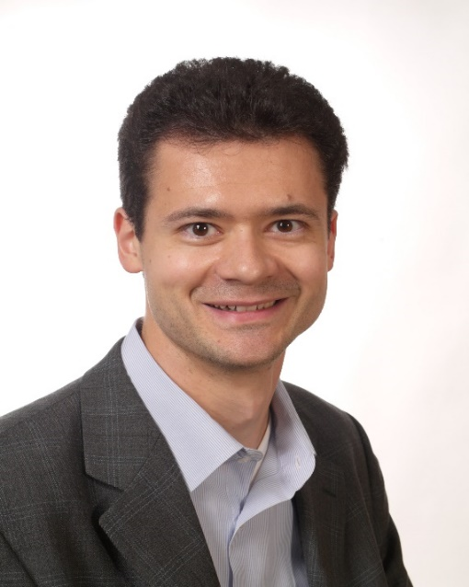

Andrea Catellani est professeur de communication à l’Université catholique de Louvain (Belgique). Il est président du jury du master en communication. Il anime le Groupe d’études et de recherche « Communication, environnement, science et société » de la Société française des sciences de l’information et de la communication (SFSIC). Il est "lead project investigator" du projet "Overcoming Obstacles and Disincentives to Climate Change Mitigation", JPI Climate (https://change4climate.eu/). Il a publié différents articles et ouvrages notamment sur la communication et la rhétorique environnementales, les discours sur la responsabilité sociétale des organisations, l’approche sémiotique des organisations, l’éthique en communication et la relation entre religion et communication dans le monde numérique.
Andrea Catellani is tenured Professor of Communication at the Catholic University of Louvain (UCLouvain, Belgium). He is president of the jury of the master program in communication. He leads the Study and Research Group "Communication, Environment, Science and Society" of the French Society of Information and Communication Sciences (SFSIC). He is "lead project investigator" of the project "Overcoming Obstacles and Disincentives to Climate Change Mitigation", JPI Climate (https://change4climate.eu/). He has published various scientific articles and books, notably on environmental communication and rhetoric, discourses on the societal responsibility of organizations, the semiotic approach to organizations, ethics in communication and the relationship between religion and communication, particularly in the digital world.

