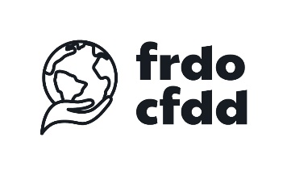
Programme | 21/12/2023
Implementing green budgeting in Belgium:what does it mean ?
- 09:00 – 09:30: Registration
- 09:30 – 09:40: Welcome and introduction
Patrick DUPRIEZ, Chairman of the FRDO-CFDD
- 09:40 – 10:00: Green budgeting in the EU
Simona POJAR, EU Commission DG ECFIN
- 10:00 – 10:20: What can we expect from green budgeting and what are the main
challenges ?
Chloé BOUTRON, Institute for Climate Economics and University of British Columbia
- 10:20 – 10:50: Q&A and debate
- 10:50 – 11:05: Green budgeting in Austria
Kerstin HAIDER and Jose DELGADO, Austrian Federal Ministry of Finance (online)
- 11:05 – 11:15: Q&A and debate
- 11:15 – 11:30: The Belgian Federal inventory of fossil fuel subsidies
Samantha HAULOTTE and Jean-Baptiste TRAVERSA, Belgian Federal Public Service Finance
- 11:30 – 11:40: Q&A and debate
- 11:40 – 11:55: Green and sovereign bonds in Belgium
Maric POST, Belgian Debt Agency
- 11:55 – 12:05: Q&A and debate
- 12:05 – 12:20: Sustainable public procurement in Belgium
Jo VERSTEVEN, Federal Institute for Sustainable Development
- 12:20 – 12:30: Q&A and debate
- 12:30: Conclusions and end of the seminar
Brent BLEYS, University of Ghent, chairman of the seminar
- 12:30 – 14:00: Sandwich buffet
Ask your question and vote for other people's questions via Slido:  Or:  https://app.sli.do/event/xhb7G6MEjmF1rJr9Ng8Eai | Evaluate the conference to improve future FRDO-CFDD  events  Or:  https://forms.office.com/e/qsCMg7rjQg?origin=lprLink | After the conference, watch the presentations and the recording:  https://frdo-cfdd.be/en  - Agenda -> Events -> 20231221

